In 2013, Finotelli and Sciortino discuss the current state of European visa policies and immigration control. From the 1980s onwards, European government have attempted to enforce a restrictive immigration and asylum strategy, as a result of illegal migration. This has led to Europe being referred to as ‘Fortress Europe’ by various researchers. Nevertheless, in 2013 it was estimated that European countries hosted up to 3.8 million irregular immigrants (immigrants who did not possess the required authorization). In addition, it was estimated that several million irregular immigrants acquired legal status through special programs. Also, it was reported that almost three out of four immigrants in the Italian amnesty program had entered the country legally.

Meuleman and Reeskens (2008) divided the (at that time) 27 member states of the EU into three classes, showing how tolerant the population of each country is towards immigration. The first class included the 9 most tolerant countries (U.K., Portugal, Spain, Italy, the Netherlands, Belgium, Norway, Sweden and Finland), followed by the second class (France, Germany, Switzerland, Luxembourg and Ireland) and the third class (Greece, Denmark, Austria, Czech Republic, Hungary, Slovakia, Poland, Lithuania, Latvia and Estonia). It should be noted that some countries have a longer history of immigration than others, which could explain the differences. Moreover, it shows that although the EU tries to harmonize immigration policies, populations of different countries have different opinions.

The Schengen Agreement was signed by European leaders in 1985, and allows citizens of 26 member states to enter, live and even work in countries within the Schengen Area without any restrictions [1]. This has created a unified European market, in which border control could be eliminated and both goods and people can be moved freely. Altogether, this unified market has reduced bureaucracy and increased collaboration between member states. However, allowing goods and people to move around member states can also have an effect on immigration.

For example, a visitor on a visa entering Spain could continue to other member states, even though an additional visa would have officially been required to do so. At the same time, when Greece became a member state it did not lead to a migration of its lower class population to wealthier member states [3].

Figure 1 shows the distribution of immigrants in Europe in the year 2017. Since the percentage of immigrants with an ‘unknown’ origin is very low, the administration of immigration in Europe appears to be accurate. It can also be observed that Germany takes the largest number of immigrants by far, and that the first five countries (*Germany, United Kingdom, Spain, Italy* and *France*) together take the very vast majority of all immigrants in Europe. However, it should also be noted that that these countries are some of the largest countries on the continent, both in terms of area size and population.

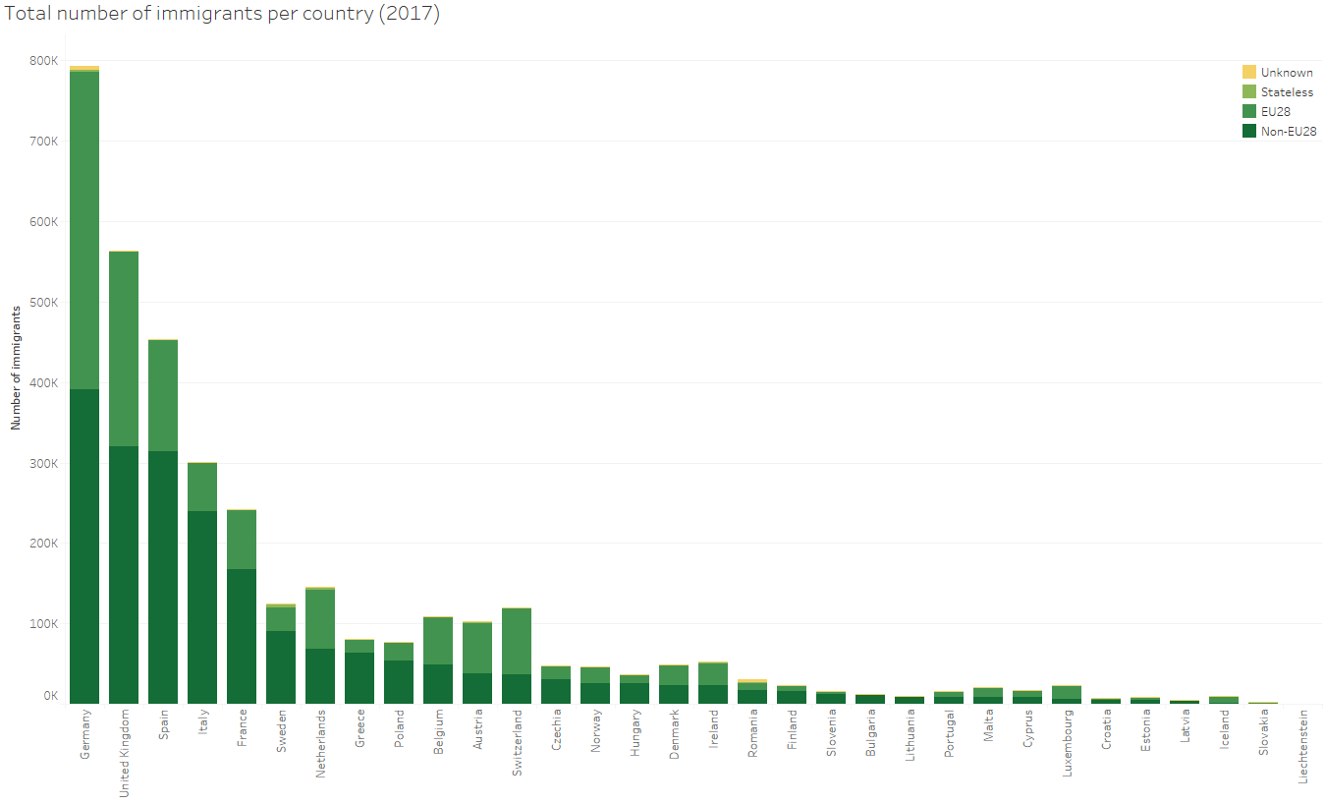

Figure 1: Total number of immigrants per country (2017).

Therefore, it is more interesting to compare the number of non-EU28 immigrants for each country to its own population and observe the relative distribution of immigrants in Europe. Figure 2 shows the immigrants per 1000 inhabitants of each European country. Here, some of the smallest countries appear to take the highest number of immigrants when compared to their own population. In Figure 2, Spain, Germany and the United Kingdom rank average, with Italy and France ranking below average.

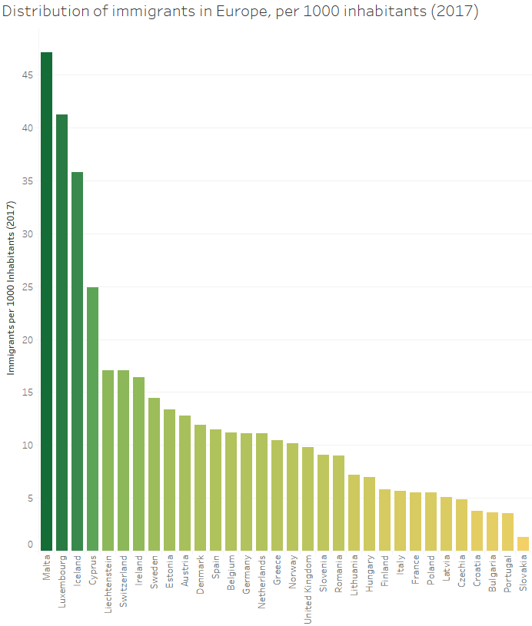

Figure : Distribution of immigrants in Europe, per 1000 inhabitants (2017)

>> Compare number of immigrants to country’s GDP.

[1] Davis, D., & Gift, T. (2014). The positive effects of the Schengen agreement on European trade. *The World Economy, 37*(11), 1541-1557.

[2] Finotelli, C., & Sciortino, G. (2013). Through the gates of the fortress: European visa policies and the limits of immigration control. *Perspectives on European Politics and Society, 14*(1), 80-101.

[3] Guild, E., & Bigo, D. (2017). Policing at a distance: Schengen visa policies. In Controlling Frontiers (pp. 233-263). Routledge.

[4] Meuleman, B., & Reeskens, T. (2008). The relation between integration policy and majority attitudes toward immigration. An empirical test across European countries. Dag van de Sociologie, Leuven.